***SPANNING TREE PROTOCOL (STP)***

1. ***Apply STP on the given LAN switches and find out which ports are Root Ports, Designated Ports, or Blocking Ports.***

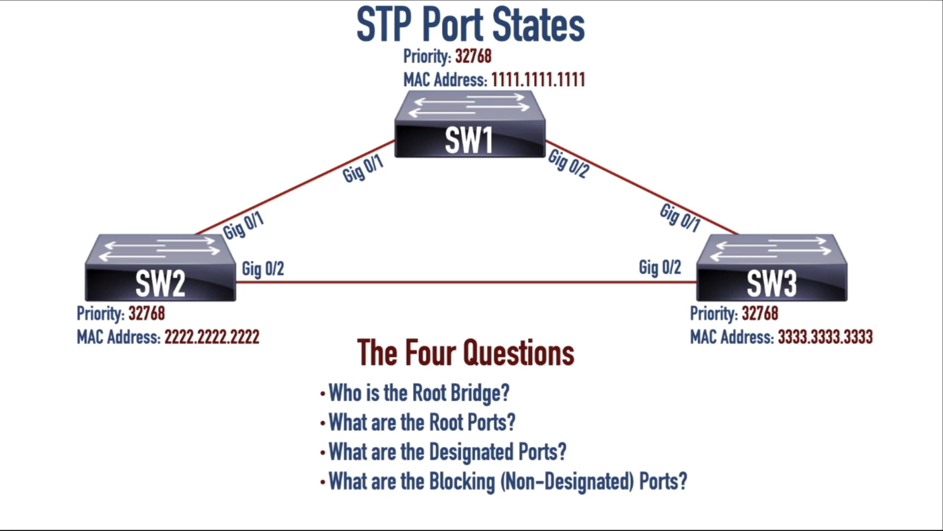



***SOLUTION:***

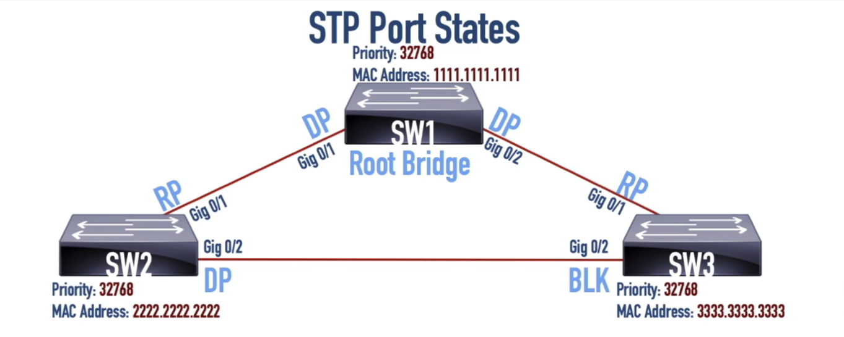

1. ***Apply STP on the given LAN switches and find out which ports are Root Ports, Designated Ports, or Blocking Ports.***

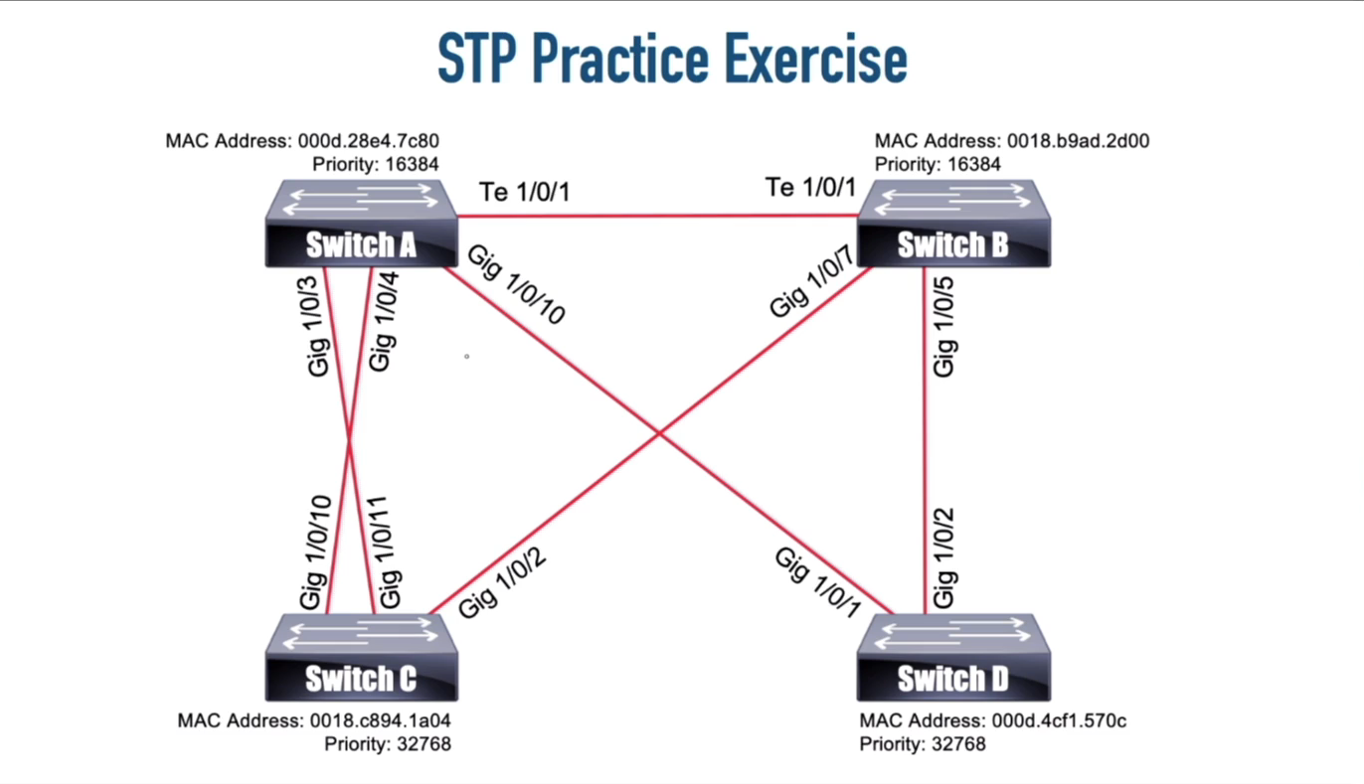

***SOLUTION:***

